Student Spent Analysis

Power BI Project

Project Background-

There are many stores in which a survey was conducted based on students i.e. How much they are spending on different kinds of purchases like Video games, Indoor games, Toys, Books, Gadgets, etc. In the data set (Student Survey), the Store setting is the column that explains the Type of location in which the store is present. By using a data set (Student Survey), try to extract meaningful Insights.

Data set –

“Student survey” is the dataset that we are using in this project. This dataset contains two columns namely Student Survey and Student Mappings.

The dataset provided is very clean so we can directly proceed with the Data Modelling phase.

Data Modelling Phase-

This is a very important part of our entire project. In This phase, we create relationships between tables. In this case, I created the many-to-many relationship between the student survey table and the student mapping table.

1. Tabular Visualization –

Here I format the total amount of purchase (TAP) based on ‘Store location’ and ‘Store setting’ using the following condition:

* + - If 0<TAP<35000, then records should be in red colour
    - If 35000<=TAP<60000, then records should be in yellow colour
    - If TAP>=60000, then records should be in blue colour

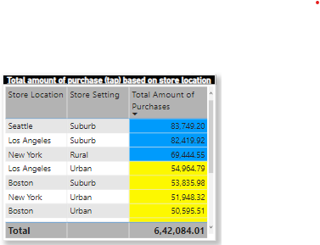

1. Matrix Visualization –

Here I created a matrix visualization to show the amount spent on Outdoor sports across different ages and ‘Store setting’.

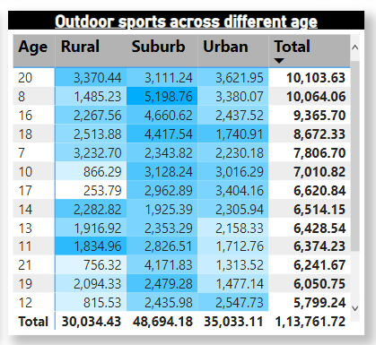

1. Funnel chart –

Here I Creating a Funnel chart to show the Total amount of purchases by ‘Store setting’.

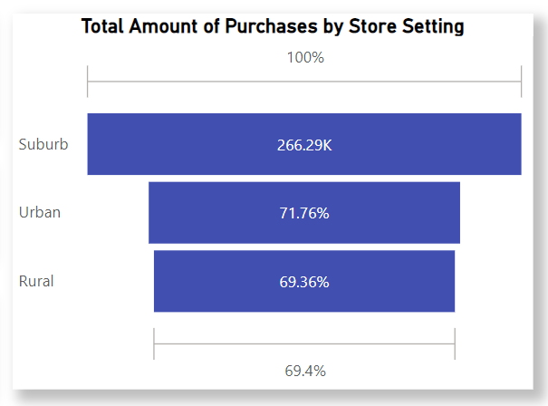

1. Pie chart –

Here I created a pie chart to show the total amount of purchase by different store location for suburban store setting:

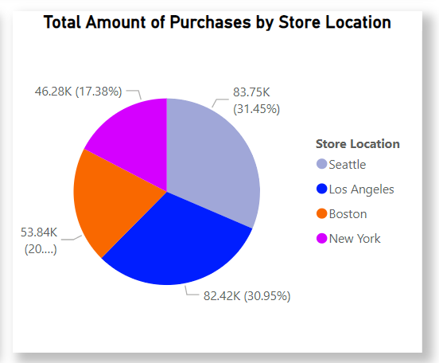

1. Scatter plot –

Here scatter plot is made to show Video games purchase and Outdoor sports spent across the different ages.

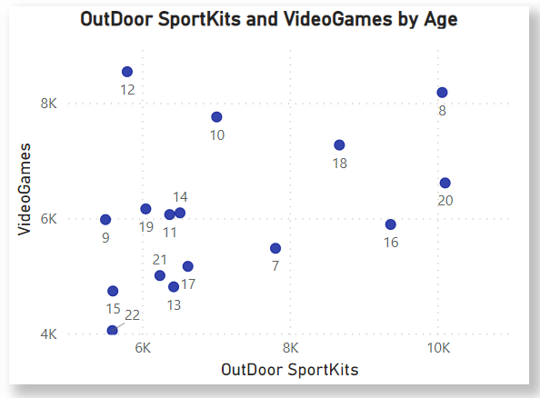

6 Sand dance plot –

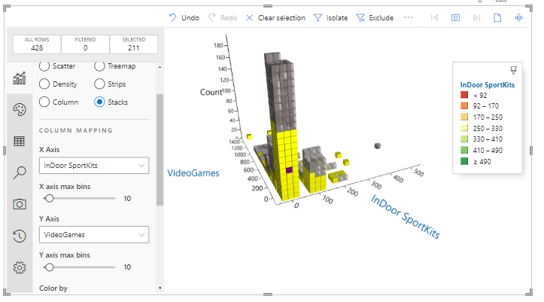

7) Publish the report-

After creating the report I publish the report in the power bi service.

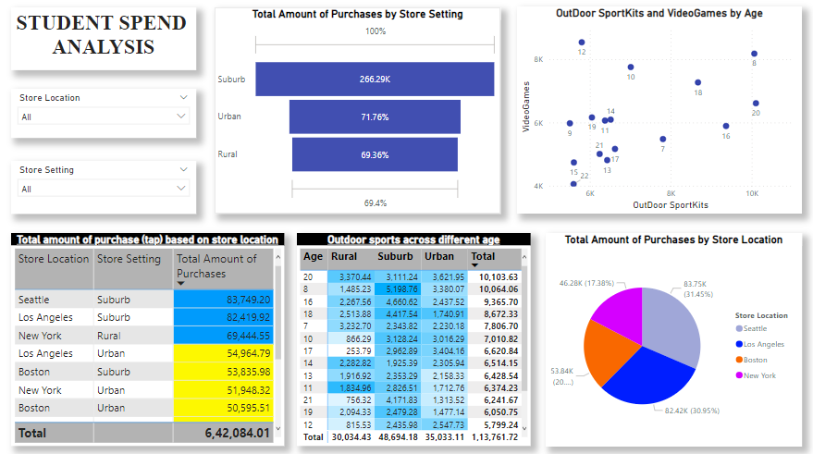

8) Scheduling the refresh five times every four hours in the day:

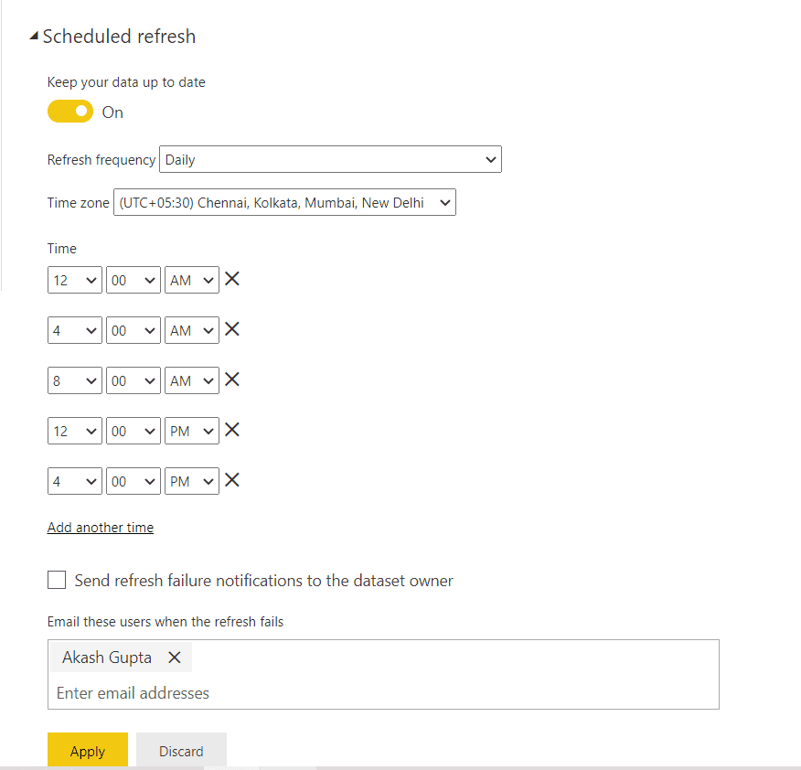

9) Using the Q&A feature to find the total amount of purchase by store location and visualize it using the pie chart:

